MAIN PAGE
NATURAL WOOD SIDING & SOFFIT
(Timeless Warmth, Lasting Impact)
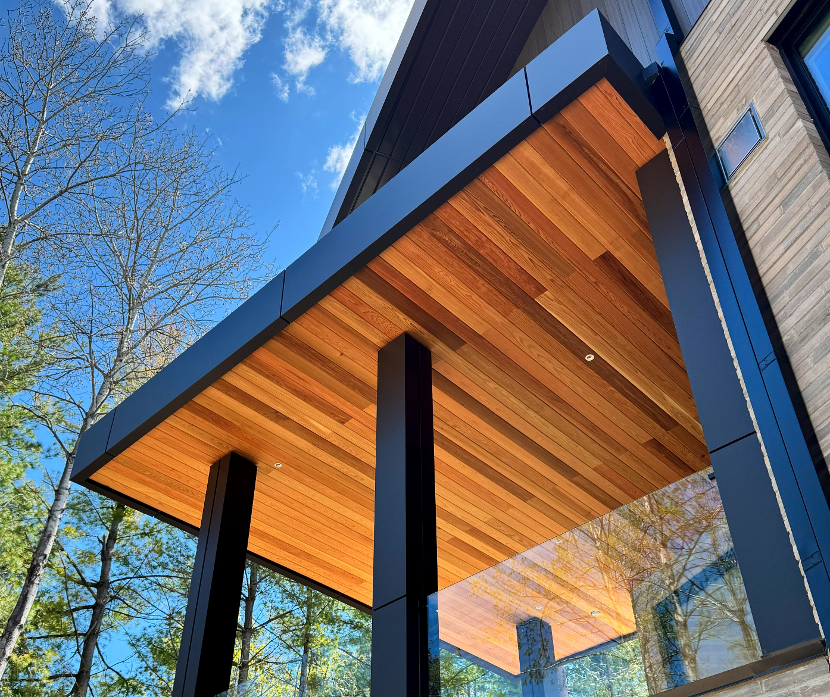
Industrial / Residential / Commercial / Agricultural
At CladCan, we bring you the unmatched character of real wood through a premium collection of siding and soffit products designed to elevate any exterior. Our line includes carefully selected natural cedar, various genuine wood species, engineered wood siding options, and distinctive styles such as board and batten and tongue-and-groove.
From the rustic charm of Eastern white cedar to the dramatic elegance of charred wood finishes, each product is built for lasting performance and visual appeal. Kiln-dried and precision-milled for stability, our wood sidings are available raw, factory-stained, or custom-finished to match your design vision.
Prefer low-maintenance solutions? Our engineered options deliver the rich look of wood with enhanced durability and weather resistance—ideal for modern builds and high-performance exteriors.
Whether you’re after natural beauty, bold texture, or a maintenance-friendly alternative, our wood siding and soffit collection offers timeless design with lasting value.
Speak with an Expert Get personalized advice and expert guidance to achieve your project goals with confidence.

NATURAL WOOD SIDING & SOFFIT (PREVIEW)

BOARD & BATTEN WOOD SIDING- ICON
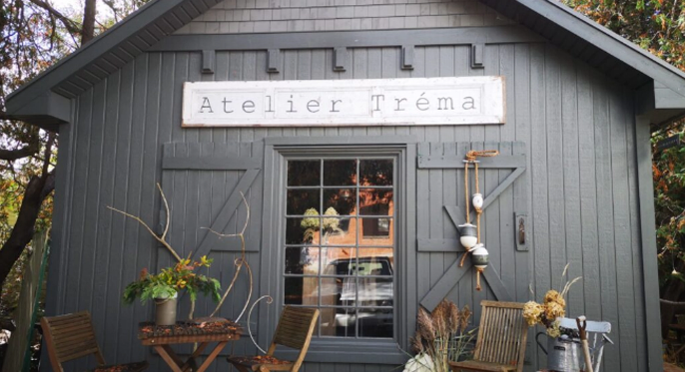
A timeless classic reimagined for modern living.
Rooted in traditional farmhouse architecture, Board & Batten siding has become a favourite among homeowners, architects, and designers for its bold vertical lines, rustic character, and clean, contemporary edge..... (Learn More / Expand)

BOARD & BATTEN WOOD SIDING (EXPANDED)
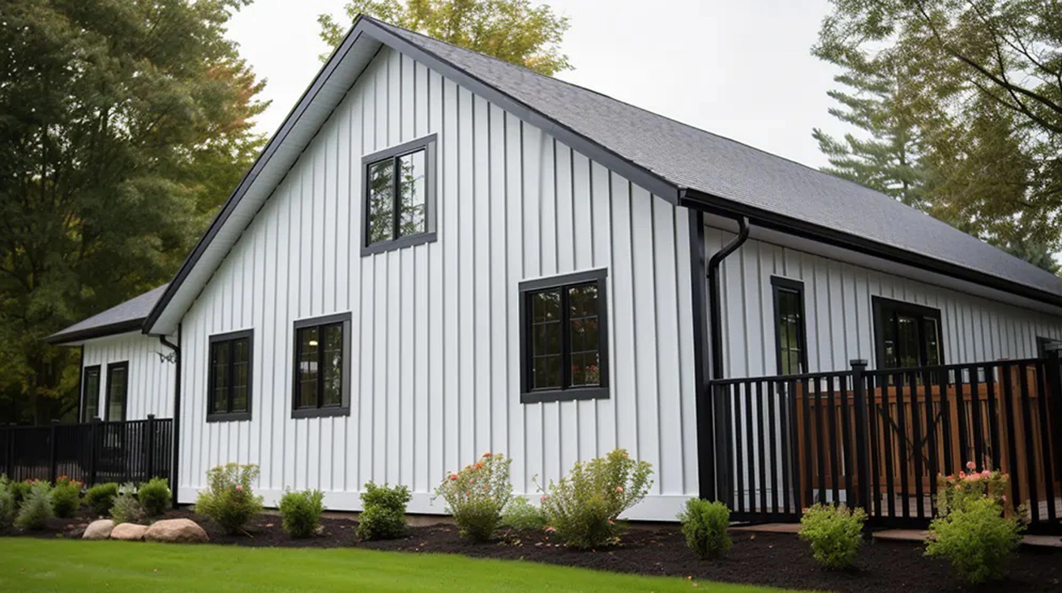
Expanded … A timeless classic reimagined for modern living.
Rooted in traditional farmhouse architecture, Board & Batten siding has become a favourite among homeowners, architects, and designers for its bold vertical lines, rustic character, and clean, contemporary edge.
This style features wide vertical boards paired with narrow battens that cover the seams—creating a distinctive rhythm and dimensional depth across the façade.
Maibec Board & Batten siding delivers the perfect blend of rustic authenticity, modern sophistication, and reliable performance—making it an ideal choice for homeowners who want lasting curb appeal without compromising on charm or quality.

Finishes:

Textured Finish
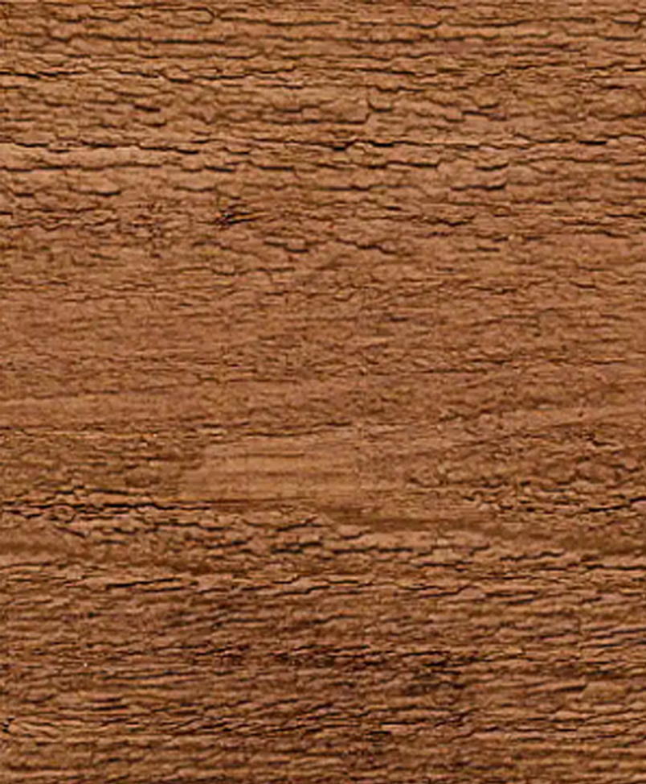
What sets Cladcan’s Board & Batten apart is the authentic woodgrain texture, enhanced by your choice of textured or brushed-face finishes. The look is organic and inviting, bringing out the richness and warmth of genuine wood while elevating the overall design with architectural finesse.
• 50-year limited warranty against wood decay
• Up to 15 years on solid stain (2-coat application)
• 8 years on Natural Tones finish
• 5 years coverage on labour
Certain conditions and exclusions apply

Profile Details:

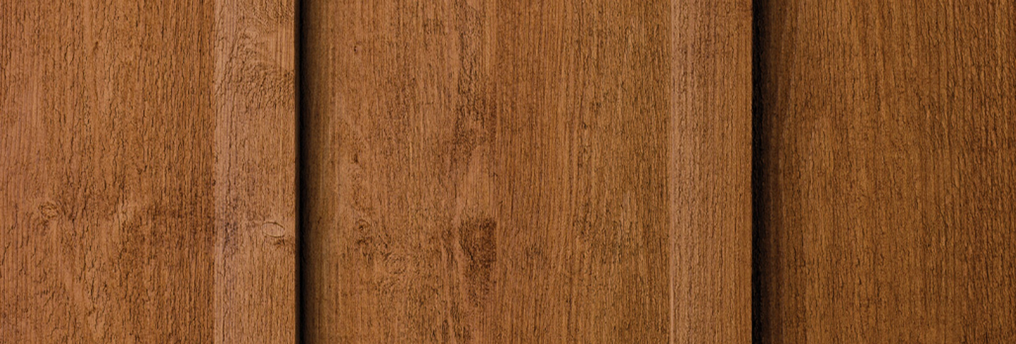
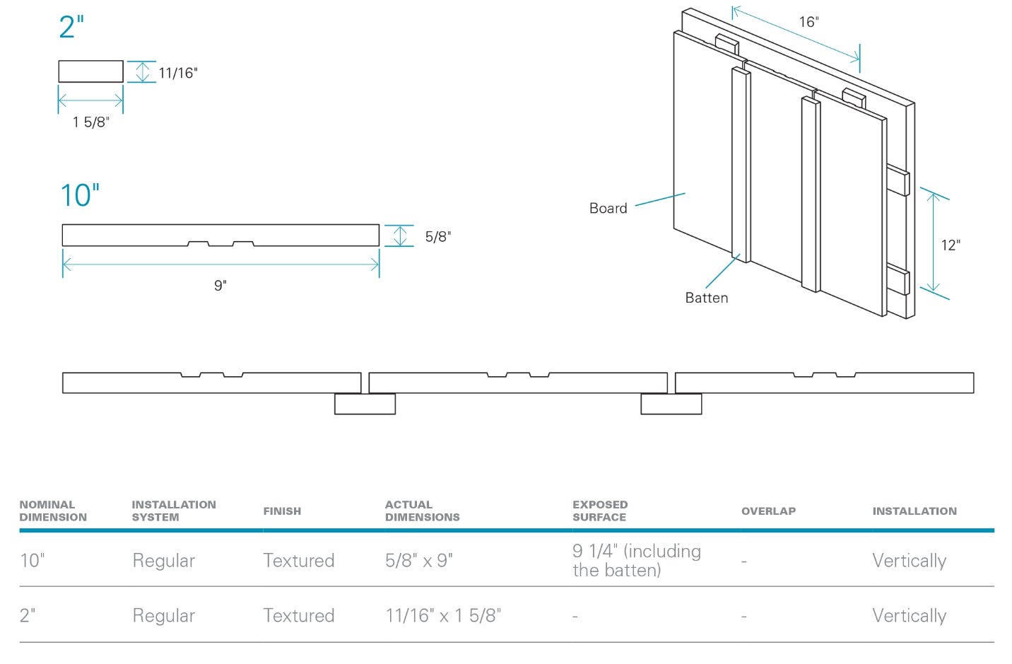

General Specifications
Wood Species
- Spruce–Pine–Fir (SPF) with sound tight knots, ensuring a balance of strength, durability, and authentic natural character.
Processing & Finishing
- Kiln-dried to a moisture content between 12% and 16% for dimensional stability and optimal performance in exterior applications.
- Offered in a classic textured finish that highlights the grain and warmth of real wood.
Length & Packaging
- Supplied in random lengths ranging from 4’ to 16’, bundled for efficient handling
- Also available in uniform 10’ lengths for applications that require consistent sizing.
Factory Coating
- Every board is factory-coated on all six sides in a climate-controlled environment for optimal stain penetration and long-lasting performance
- Enhanced UV and weather protection
- Uses low-VOC, water-based stains for a safer, more sustainable finish
Warranty
- Every board is factory-coated on all six sides in a climate-controlled environment for optimal stain penetration and long-lasting performance
- Enhanced UV and weather protection
- Uses low-VOC, water-based stains for a safer, more sustainable finish
Available Colours & Textured Finish
- Choose from the full Solid Stain Colour Chart
- Select from our signature Natural Tones collection
- Or create your own custom look with the TrueMatch® system — offering an unlimited range of solid colours, all applied in two high-quality coats for exceptional coverage and durability.
For exterior applications only.

Discover a World of Colour
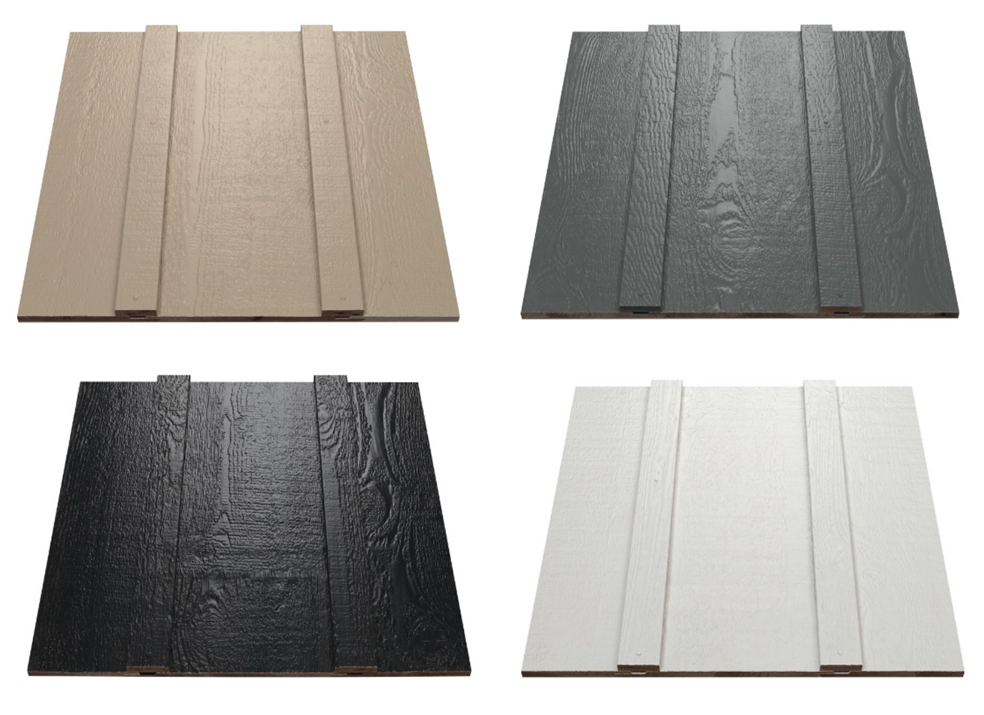
Whether you’re aiming for a classic countryside charm or a sleek modern farmhouse aesthetic, this siding style adapts effortlessly to various settings. It’s available in an impressive array of solid colours and natural stains—including custom options through the Maibec TrueMatch® system—so you can create a truly personalized exterior.
Beyond its aesthetic appeal, the design’s robust, thick panel construction adds real-world durability with reduced maintenance demands. Factory-stained on all six sides, each board is engineered to resist the elements, retain its colour, and protect your investment over time.

Embrace the Beauty of Natural Variation
Love the subtle depth and character only real wood can offer? Our Natural Stains are designed to highlight those unique variations in tone, grain, and texture—bringing a rich, organic feel to every board. The result is a naturally dimensional look that’s both timeless and inspiring.
Thanks to Maibec’s exclusive finishing process, you get the authentic charm of semi-transparent stains with enhanced durability and reduced upkeep. Available in both textured and brushed-face finishes, our curated palette of twelve Natural Stains lets you achieve the perfect balance between natural beauty and long-lasting performance.
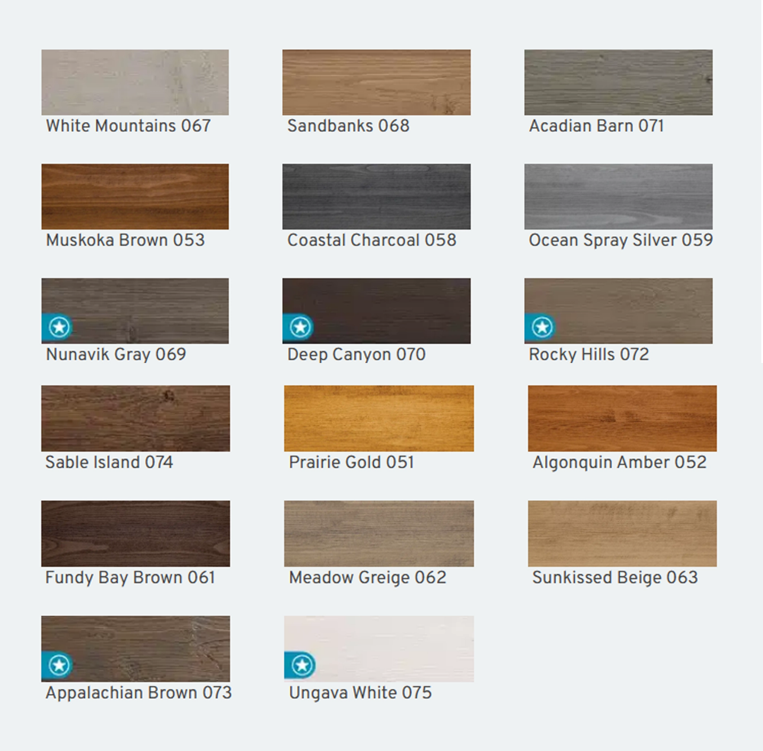
Solid Colors
Five professionally curated, nature-inspired solid colour palettes—now available in both textured and brushed-face finishes for greater design flexibility.

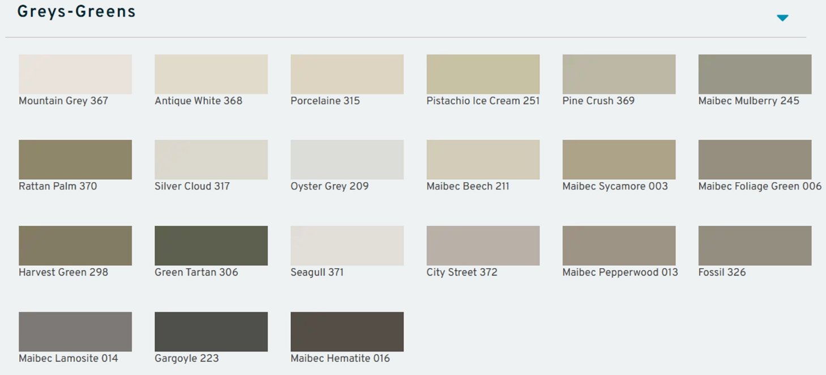
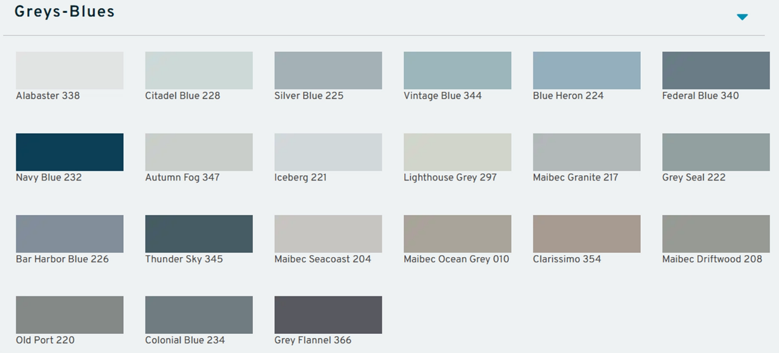
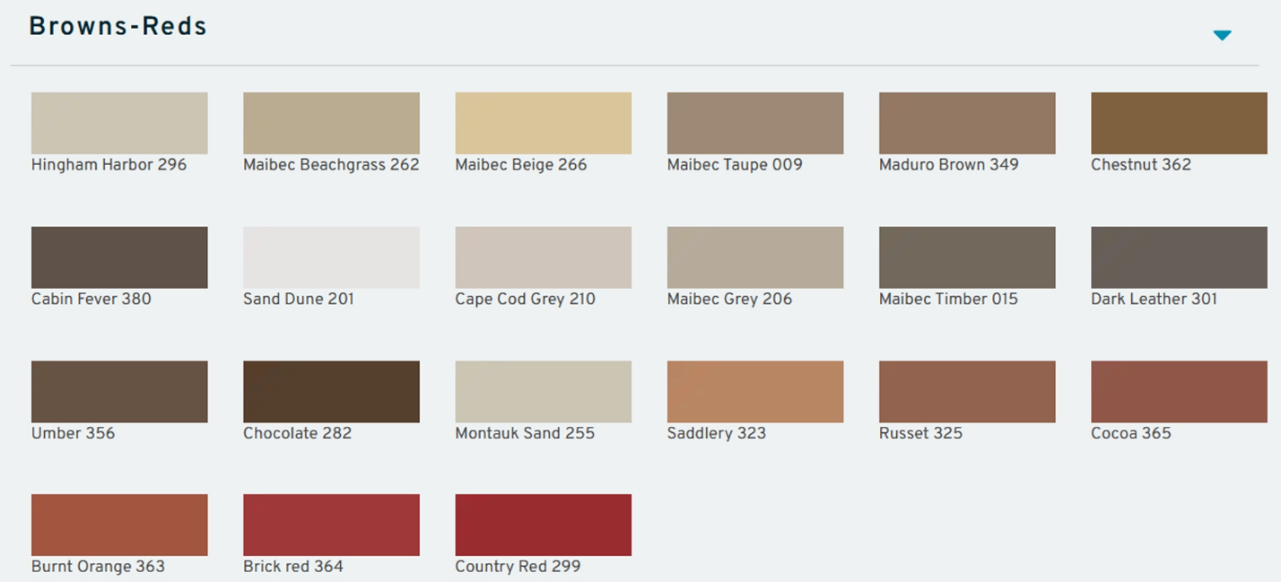
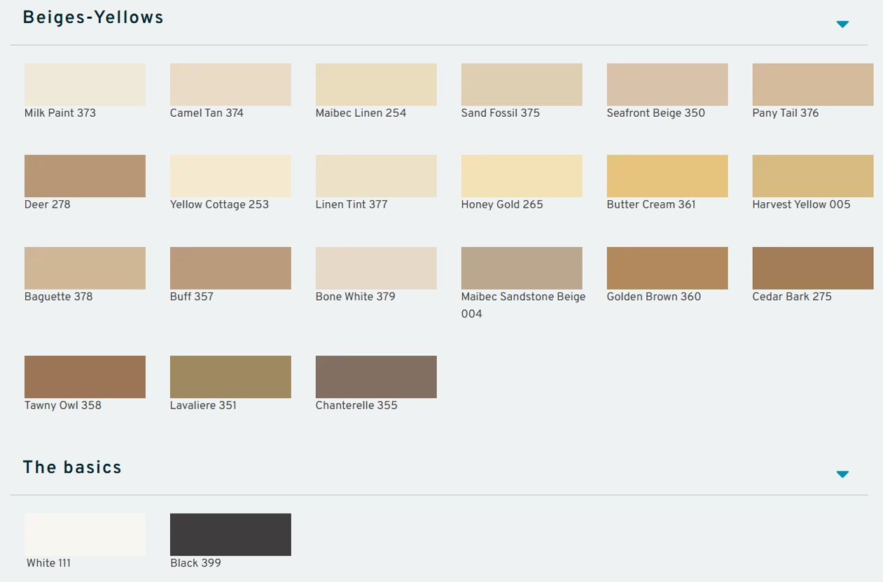

Personalized Colours, Perfectly Matched
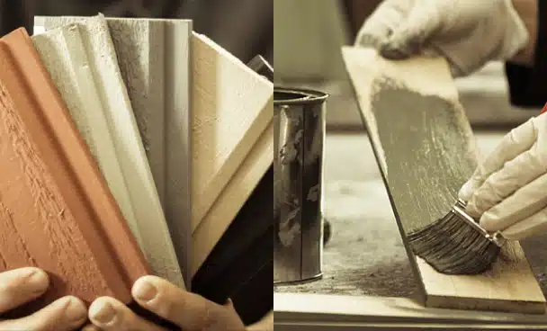
Have a specific colour in mind? With our proven TrueMatch® system, we’ll create a precise solid stain match to bring your vision to life. No matter the shade you choose, every board is coated with our premium-quality stain—factory-applied on all six sides for lasting beauty and protection.

